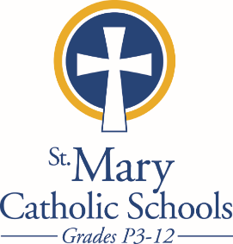
Ordering Scrip through
the Summer is EASY!

Order online with PrestoPay by 9:00 am each Monday for the most convenient ordering and payments.

Paper orders and check payments need to be hand-delivered to:
St. Mary Catholic High School (SMCHS) by 9:00 am each Monday.
Pick up from 11:00-3:00 each Thursday at SMCHS. Additional hours listed below.

There are also some limited hours of pick up at the following parishes (contact the parish for hours):
St. Gabriel Parish
St. Margaret Mary Parish
St. Patrick’s Parish

You may already have a SUMMER PARISH pick up in place. See “Delivery Method” below your name on your order. If it says “SUMMER” and a parish name behind your usual pick up location, that is where your order will be available during the summer Scrip schedule.
Please email jlee@smcatholicschools.org or swautlet@smcatholicschools.org if you want to
pick up your Scrip from one of those parishes and you do not already have the SUMMER parish listed.

If you do not have a SUMMER PARISH listed on your order, your Scrip will be held at SMCHS on Thursdays; available for pick up after 11:00 am.

This year over $200,000 in Scrip rebates were given back
to families, participating parishes and the school system! Please remind your friends and family to keep the Scrip habit going.
Thank you for using Scrip!

Summer Hours – SMCHS:
Monday–Friday: 8:00 a.m. to 12:00 p.m.
With extended Scrip pick up hours Thursdays from 11:00 a.m. to 3:00 p.m.

