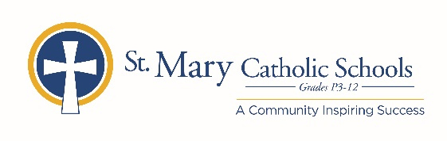

MEDIA RELEASE

August 10, 2020 (updated from July 16, 2020)

FOR FURTHER INFORMATION CONTACT:
Jennifer Miller
Director of Communications
St. Mary Catholic Schools
1050 Zephyr Drive
Neenah, WI 54956
Phone: 920-722-7796 ext. 206 mailto:jmiller@smcatholicschools.org

FOR IMMEDIATE RELEASE

Zephyrs Connect to Benefit SMCS Booster Club, Fine Arts and Technology

NEENAH/MENASHA: Zephyrs Connect is a non-competitive run/walk that helps raise money for St. Mary Catholic Schools’ Booster Club, Fine Arts, and Technology departments. It also helps support our five parishes; St. Gabriel Parish, St. John Parish, St. Margaret May Parish, St. Mary Parish, and St. Patrick’s Parish. The entire community is encouraged to participate! This 5k run/walk will begin and finish on the campus of St. Mary Catholic Middle/High School at 1050 Zephyr Drive in the Village of Fox Crossing. Entertainment and a FREE catered dinner will be provided for ALL who attend (runners and spectators).
The evening concludes with our Zephyrs Fields Grand Opening! We will dedicate this $2.5 Million NCAA regulation fields project, equipped with an MTS Pro synthetic turf field for soccer and football and an 8-lane 400-meter Zephyrs Blue synthetic polyurethane championship running track. Also included as part of the new sports complex are collegiate level designed pole vault, long jump, discus, shot put and high jump areas all visible from the grandstand. It also is enhanced with a new LED track timing and scoreboard system. All sporting events will be supported with a 360-degree high-performance sound system and will include a wi-fi network for live streaming of contests.
**Please note new timeline**
Sign up for the run/walk/dinner today at https://smcatholicschools.org/
5:00 run/walk registration
5:30 kids run
6:00 run/walk
7:00 catered dinner & social
8:00 blessing and dedication of Zephyrs Fields by the Very Reverend Bishop David Ricken
8:30 fireworks

St. Mary Catholic Schools (SMCS) includes St. Mary Catholic High School and St. Mary Catholic Middle School in the Village of Fox Crossing and St. Mary Elementary Schools (St. Margaret Mary and St. Gabriel in Neenah, and St. Mary in Menasha). St. Mary Catholic High School in the Village of Fox Crossing. SMCS is dedicated to preparing and inspiring students to lead meaningful lives, rooted in the teachings of Christ in our Catholic tradition.

