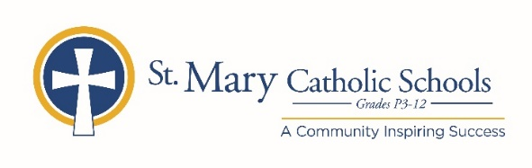

***MEDIA RELEASE***

July 6, 2020

*FOR FURTHER INFORMATION CONTACT:*

Jennifer Miller

Director of Communications

St. Mary Catholic Schools

1050 Zephyr Drive

Neenah, WI 54956

Phone: 920-722-7796 ext. 206 jmiller@smcatholicschools.org

*FOR IMMEDIATE RELEASE*

**St. Mary Catholic Schools Announces Timothy Schigur Ed. D as Superintendent**

NEENAH/MENASHA:

St. Mary Catholic Schools (SMCS) welcomes a new Superintendent, Timothy Schigur Ed. D. He assumed his leadership duties July 1, 2020.

Schigur brings with him a wealth of experience and expansive leadership qualities developed from his 22 years in both Catholic and public education. He began his career in education as a middle school history and geography teacher, serving as a school principal, and superintendent to the school district of Milton. Most recently he has worked as director of educational markets for C.D. Smith Construction Inc. in the public sector.

Schigur earned his Bachelor of Arts from Marquette University in History and Political Science, his teaching certification from University of Wisconsin-Eau Claire, his Master of Science in Educational Leadership from Cardinal Stritch University, and his Doctorate of Educational Leadership from Edgewood College.

“I am thrilled and honored to be a part of the SMCS community,” said Schigur. “It is my desire to inspire the staff and school community of St. Mary Catholic Schools, in my role of superintendent and to support all students in their Catholic educational journey.”

Past SMCS Board of Trustees President Kathleen Healy-Osland, who lead the recruiting effort, offered the following statement on behalf of the board: “Dr. Schigur comes to SMCS with a remarkable degree of experience as an accomplished educational leader. His values, strategic planning experience and collaborative leadership style make him an exceptional individual to carry forward our mission of preparing and inspiring students to lead meaningful lives, rooted in the teachings of Christ in our Catholic tradition.”

**St. Mary Catholic Schools** ([SMCS](https://smcatholicschools.org/)) includes St. Mary Catholic High School and St. Mary Catholic Middle School in the Village of Fox Crossing, Wisconsin, and St. Mary Catholic Elementary Schools (St. Margaret Mary and St. Gabriel in Neenah, and St. Mary in Menasha). SMCS is dedicated to preparing and inspiring students to lead meaningful lives, rooted in the teachings of Christ in our Catholic tradition for students in grades Pre3-12.

