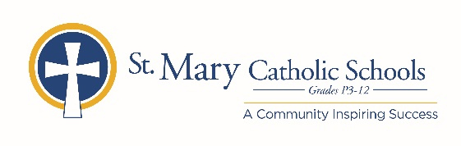

MEDIA RELEASE

July 16, 2020

FOR FURTHER INFORMATION CONTACT:
Jennifer Miller
Director of Communications
St. Mary Catholic Schools
1050 Zephyr Drive
Neenah, WI 54956
Phone: 920-722-7796 ext. 206 mailto:jmiller@smcatholicschools.org

FOR IMMEDIATE RELEASE

Zephyrs Connect to Benefit SMCS Booster Club, Fine Arts and Technology

NEENAH/MENASHA: Zephyrs Connect is a non-competitive run/walk that helps raise money for St. Mary Catholic Schools’ Booster Club, Fine Arts, and Technology departments. It also helps support our five parishes; St. Gabriel Parish, St. John Parish, St. Margaret May Parish, St. Mary Parish, and St. Patrick’s Parish. The entire community is encouraged to participate! This 5k run/walk will begin and finish on the campus of St. Mary Catholic Middle/High School at 1050 Zephyr Drive in the Village of Fox Crossing.
This event is scheduled for Friday, August 28. Participants are encouraged to register online at smcatholicschools.org. On-site registration and check in will take place from 3:00 p.m.-4:30 p.m., with entertainment and concessions opening at 4:00 p.m. The kids fun run takes off at 4:30 p.m. and the fun run/walk starts at 4:45 p.m.
Pricing is as follows:
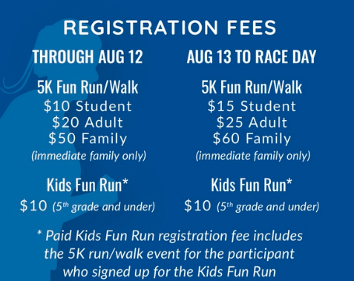
St. Mary Catholic Schools (SMCS) includes St. Mary Catholic High School and St. Mary Catholic Middle School in the Village of Fox Crossing and St. Mary Elementary Schools (St. Margaret Mary and St. Gabriel in Neenah, and St. Mary in Menasha). St. Mary Catholic High School in the Village of Fox Crossing. SMCS is dedicated to preparing and inspiring students to lead meaningful lives, rooted in the teachings of Christ in our Catholic tradition.

