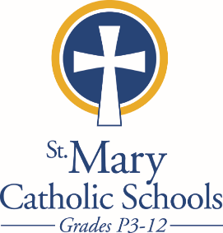
Ordering Scrip through
the Summer is EASY!

Order online with PrestoPay by 9:00 am each Monday for the most convenient ordering and payments.

Paper orders and check payments need to be hand-delivered to
St. Mary Catholic High School (SMCHS) by 9:00 am each Monday.
Pick up from 11:00-3:00 each Thursday at SMCHS. Additional hours listed below.
There are also some limited hours of pick up at the following parishes (contact the parish for hours):
St. Gabriel Parish
St. Margaret Mary Parish
St. Patrick’s Parish

You may already have a SUMMER PARISH pick up in place. See “Delivery Method” below your name on your order. If it says “SUMMER” and a parish name behind your usual pick up location, that is where your order will be available during the summer Scrip schedule.
Please email jfrink@smcatholicschools.org or swautlet@smcatholicschools.org if you want to
pick up your Scrip from one of those parishes and you do not already have the SUMMER parish listed.

If you do not have a SUMMER PARISH listed on your order, your Scrip will be held at SMCHS on Thursdays; available for pick up after 11:00 am.

Please remind all your friends, family and neighbors to keep the Scrip habit going. This year over $105,000 in Scrip credit was given back to families on their tuition accounts!

Thank you for using Scrip!

SMCHS Summer Office hours:
Monday–Friday: 8:00 a.m. to 12:00 p.m.
With extended Scrip pick up hours Thursdays from 11:00 a.m. to 3:00 p.m.

