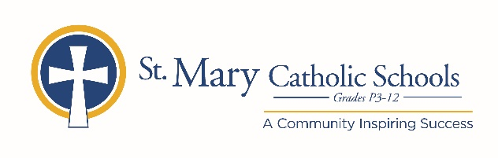

February 12, 2020

FOR FURTHER INFORMATION CONTACT:
Jennifer Miller
Director of Communications
St. Mary Catholic Schools
1050 Zephyr Drive
Neenah, WI 54956
Phone: 920-722-7796 ext. 206 mailto:jmiller@smcatholicschools.org

FOR IMMEDIATE RELEASE

SMCS to Host STEM Saturday

NEENAH, WI – St. Mary Catholic Schools (SMCS) is hosting a FREE community event for STEM (science, technology, engineering and math) enthusiasts of all ages. STEM Saturday will be held Saturday March 21 from 9:00 a.m. – 12:00 p.m. at St. Mary Catholic Middle School located at 1000 Zephyr Drive, Neenah.

Guests are invited to enjoy:
9:00 a.m.
Metallurgical Mayhem Presentation by DePere Foundry
9:40-11:30 a.m.
STEM Stations, Miracles of Magnetism and Electricity, Women and Technology, Amcor, Wonder Robots, Little Bits, Cre8lab, Boys’ and Girls’ Brigade
11:30 a.m.
Backyard Smelter Demonstration by Isaac Pifer

St. Mary Catholic Schools (SMCS) includes St. Mary Catholic High School and St. Mary Catholic Middle School in the Village of Fox Crossing and St. Mary Elementary Schools (St. Margaret Mary and St. Gabriel in Neenah, and St. Mary in Menasha). St. Mary Catholic High School in the Village of Fox Crossing. SMCS is dedicated to preparing and inspiring students to lead meaningful lives, rooted in the teachings of Christ in our Catholic tradition.

***end***

