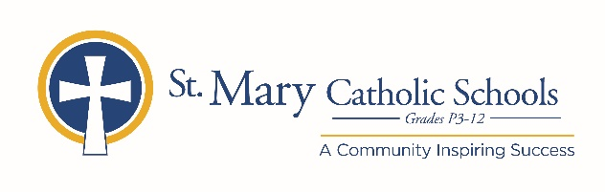

January 22, 2020

FOR FURTHER INFORMATION CONTACT:
Jennifer Miller
Director of Communications
St. Mary Catholic Schools
1050 Zephyr Drive
Neenah, WI 54956
Phone: 920-722-7796 ext. 206 mailto:jmiller@smcatholicschools.org

FOR IMMEDIATE RELEASE

SMCS to Offer Drop-In School Choice Information Session

NEENAH, WI – St. Mary Catholic Schools (SMCS) participates in the Wisconsin Parental Choice Program (WPCP), which enables families who meet the income requirements to attend St. Mary Catholic Schools free of charge. There is no cost to apply, but all applications must be submitted online via the Wisconsin Department of Public Instruction between February 3 and April 16, 2020.

To learn more about the WPCP program, attend our upcoming information session at St. Mary Catholic High School at 1050 Zephyr Drive, Neenah on Monday, February 17 from 4:00-6:00 p.m. A qualified person from the business office will be on hand to help parents/guardians determine that night if they are eligible to apply for WPCP, and help with completing the application.

If a family does not meet the state income requirements, grants and scholarships are available through the SMCS tuition assistance program. Please contact Shelley Wautlet at 920-722-7796 ext. 851 or visit smcatholicschools.org with questions.

St. Mary Catholic Schools (SMCS) includes St. Mary Catholic High School and St. Mary Catholic Middle School in the Village of Fox Crossing and St. Mary Elementary Schools (St. Margaret Mary and St. Gabriel in Neenah, and St. Mary in Menasha). St. Mary Catholic High School in the Village of Fox Crossing. SMCS is dedicated to preparing and inspiring students to lead meaningful lives, rooted in the teachings of Christ in our Catholic tradition.

***end***

