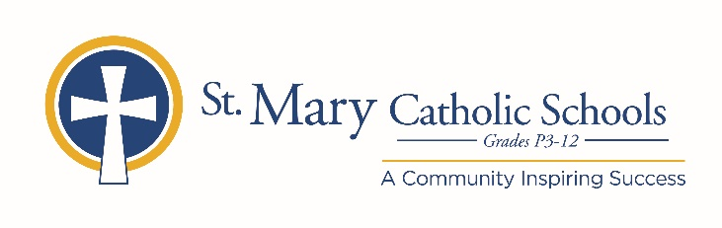

MEDIA RELEASE

January 20, 2020

FOR FURTHER INFORMATION CONTACT:
Jennifer Miller
Director of Communications
St. Mary Catholic Schools
1050 Zephyr Drive
Neenah, WI 54956
Phone: 920-722-7796 ext. 206 jmiller@smcatholicschools.org

FOR IMMEDIATE RELEASE

SMC Announces Dean Laux as Varsity Baseball Coach

NEENAH/MENASHA:
St. Mary Catholic Schools (SMCS) welcomes a new varsity baseball coach, Dean Laux. Laux joins SMCS with over eight years of baseball coaching experience, most recently working with Neenah Legion Baseball, Neenah High School, Brillion High School and our own SMC as assistant varsity coach from 2008-2010. He will be responsible for providing overall leadership for the SMCS Baseball program

“We are thrilled to have Dean back at SMC and are confident that with his expertise and extensive coaching background that he will continue to build upon our already strong foundation.” SMCS Athletic Director, Matt Schoultz said. “His starting coincides perfectly with assisting with the U.S. Baseball Academy camp hosted by SMC which starts January 26.”

St. Mary Catholic High School (SMCHS) a regional high school located in the Village of Fox Crossing, Wisconsin, is part of St. Mary Catholic Schools (SMCS). The system also includes St. Mary Catholic Elementary Schools (St. Margaret Mary and St. Gabriel in Neenah, and St. Mary in Menasha), as well as St. Mary Catholic Middle School in the Village of Fox Crossing. SMCHS is dedicated to preparing and inspiring students to lead meaningful lives, rooted in the teachings of Christ in our Catholic tradition.

