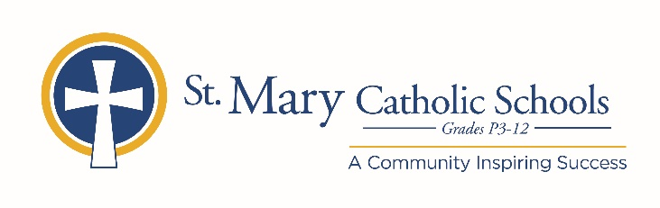

MEDIA RELEASE

January 6, 2020

FOR FURTHER INFORMATION CONTACT:
Jennifer Miller
Director of Communications
St. Mary Catholic Schools
1050 Zephyr Drive
Neenah, WI 54956
Phone: 920-722-7796 ext. 206 jmiller@smcatholicschools.org

FOR IMMEDIATE RELEASE

SMCS Announces Chris Decker as New Director of Mission Advancement

NEENAH/MENASHA:
St. Mary Catholic Schools (SMCS) welcomes a new Director of Mission Advancement, Chris Decker. Decker joins SMCS with over 15 years of leadership experience, most recently as the associate pastor with New Hope in Neenah, WI. He will be responsible for designing and implementing a comprehensive advancement plan to support all aspects of philanthropic giving. Decker graduated from Concordia University, Chicago with a Communication degree followed by a Master of Divinity from Concordia Seminary, St. Louis.

“I am overjoyed by the opportunity to join St. Mary Catholic Schools,” Decker said, “This position gives me the chance to share my passion for the schools and the personal experiences my family have been blessed to receive. I want to do my part to make SMCS the premier school system in the Fox Valley.”

“We are delighted to have Chris join our SMCS team and are confident that with his strong background in fundraising, cultivating relationships and gaining consensus, he will be able to achieve powerful results for SMCS,” SMCS President, Helen Englebert said. “His starting coincides perfectly with work that needs to be done with our newly formed St. Mary Catholic Schools Foundation.”

St. Mary Catholic Schools (SMCS) includes St. Mary Catholic High School and St. Mary Catholic Middle School in the Village of Fox Crossing, Wisconsin, and St. Mary Catholic Elementary Schools (St. Margaret Mary and St. Gabriel in Neenah, and St. Mary in Menasha). SMCS is dedicated to preparing and inspiring students to lead meaningful lives, rooted in the teachings of Christ in our Catholic tradition for students in grades Pre3-12.

