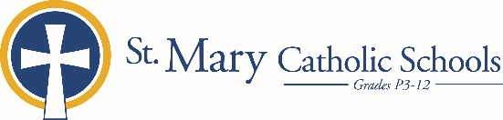

MEDIA RELEASE

December 9, 2019

FOR FURTHER INFORMATION CONTACT:
Jennifer Miller
Director of Communications
St. Mary Catholic Schools
1050 Zephyr Drive
Neenah, WI 54956
Phone: 920-722-7796 ext. 206 jmiller@smcatholicschools.org

FOR IMMEDIATE RELEASE

St. Mary Elementary Presents Winter Escape

Winter Escape is an annual fundraising event that benefits St. Mary Elementary School. This event takes place on January 24, 2020 from 7:00-10:00 p.m. in the in the St. Mary Elementary gym at 540 Second Street, Menasha. Tickets may be purchased online at: https://tcces.ejoinme.org/WinterEscape2020

The theme of the night is an evening in Hawaii. You will be welcomed with the music of Hale O Malo Productions to transport you to the islands of Hawaii, where you will have an opportunity to learn the hula and see a light dance. Your palate will savor the tropical fare provided by The Cozzy Corner! Wash down the tasty tidbits with a drink from the cash bar or go Hawaiian with a tropical, fruity umbrella drink! There will also be raffles, a silent auction, and games with fabulous prizes! And you don't want to miss the Live Pig Auction! Join us for some fun, food, and fellowship, all supporting the students and school!

The proceeds from this event will assist with the cost of technology costs and classroom resources.

St. Mary Elementary School, located in Menasha, Wisconsin, is part of St. Mary Catholic Schools (SMCS). The system also includes St. Margaret Mary and St. Gabriel Elementary Schools in Neenah, and St. Mary Catholic Middle School and St. Mary Catholic High School in the Village of Fox Crossing. SMCS is dedicated to preparing and inspiring students to lead meaningful lives, rooted in the teachings of Christ in our Catholic tradition.

*end*

