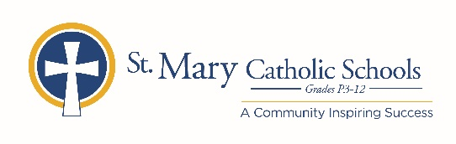

MEDIA RELEASE

November 11, 2019

FOR FURTHER INFORMATION CONTACT:
Director of Communications, Jennifer Miller
St. Mary Catholic Schools
1050 Zephyr Drive
Neenah, WI 54956
920-722-7796 ext. 206 jmiller@smcatholicschools.org

SMCS Presents Christmas Concerts

FOR IMMEDIATE RELEASE

Fox Cities: St. Mary Catholic Schools is celebrating the seasons of Advent and Christmas with a series of Christmas programs. All concerts will be held at 6:30 p.m. at the Jane Bergstrom Fine Arts Education Center at 1050 Zephyr Drive, Neenah.

December 4 St. Mary Catholic Middle & High Schools Combined Choir Concert
December 9 St. Mary Elementary School Christmas Concert
December 10 St. Gabriel Elementary School Christmas Concert
December 12 St. Margaret Mary Elementary School Christmas Concert
December 16 St. Mary Catholic Middle & High Schools Combined Band Concert
December 17 SMCS Elementary Schools Band Concert

St. Mary Catholic Schools (SMCS) includes St. Mary Catholic High School and St. Mary Catholic Middle School in the Village of Fox Crossing and St. Mary Catholic Elementary Schools (St. Margaret Mary and St. Gabriel in Neenah, and St. Mary in Menasha). SMCS is dedicated to preparing and inspiring students to lead meaningful lives, rooted in the teachings of Christ in our Catholic tradition.
***end***

