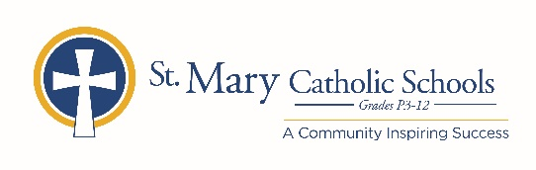

MEDIA RELEASE

October 10, 2019

FOR FURTHER INFORMATION CONTACT:
Director of Communications, Jennifer Miller
St. Mary Catholic Schools
1050 Zephyr Drive
Neenah, WI 54956
920-722-7796 ext. 206 jmiller@smcatholicschools.org

St. Mary Catholic Schools to Host Z-Night

FOR IMMEDIATE RELEASE

Neenah/Menasha: Supporters of St. Mary Catholic Schools (SMCS) will gather at Waverly Beach in Menasha on Saturday, November 9, 2019 from 6:30 - 11:00 p.m. for a fun-for-adults annual Z-NIGHT fundraiser.

Z-NIGHT promotes unity and fellowship among our entire community – alumni, school parents, parishes and community supporters. With plenty of fun, games, great food and music by the band Road Trip, Z-NIGHT will be a festive evening for all.

Z-NIGHT proceeds help provide the means to offset operational costs, maintain our facilities and purchase instructional materials for all five SMCS schools Admission tickets are only $25 per person, and are available online at smcatholicschools.org, or at any SMCS school.

St. Mary Catholic Schools (SMCS) includes St. Mary Catholic High School and St. Mary Catholic Middle School in the Village of Fox Crossing and St. Mary Catholic Elementary Schools (St. Margaret Mary and St. Gabriel in Neenah, and St. Mary in Menasha). SMCS is dedicated to preparing and inspiring students to lead meaningful lives, rooted in the teachings of Christ in our Catholic tradition.
***end***

