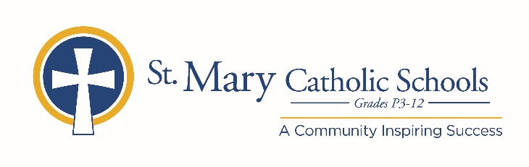

MEDIA RELEASE

October 16, 2019

FOR FURTHER INFORMATION CONTACT:
Jennifer Miller
Director of Communications
St. Mary Catholic Schools
1050 Zephyr Drive
Neenah, WI 54956
Phone: 920-722-7796 ext. 206 jmiller@smcatholicschools.org

FOR IMMEDIATE RELEASE

SMCHS Presents Snapshots: A Musical Scrapbook

St. Mary Catholic High School (SMCHS) is pleased to announce the upcoming fall musical, Snapshots: A Musical Scrapbook, which will take place on November 24, 2019 at 2:00 p.m., November 25, 2019 at 7:00 p.m. and November 26, 2019 at 4:00 p.m. The play will be at SMCHS located at 1050 Zephyr Dr, Neenah and will be in the Jane Bergstrom Fine Arts Education Center. Tickets are available to purchase at SMCSFineArts.org. General Admission is $12 and Student/Senior Admission is $10.

An original new musical featuring the beloved songs from Academy Award-winning composer Stephen Schwartz (Wicked, Pippin, Godspell), Snapshots: A Musical Scrapbook is a touching and authentic look into how we fall in love and the poignant power of trusting our hearts and memories. Sue has her bags packed, her farewell note written and the resolution to leave her husband, Dan, after decades of their lives entwined. Finding herself in their dusty, suburban attic for a final goodbye to the life they led, Sue is startled when Dan arrives home early from his all-consuming job. Surrounded by a lifetime of memories and phantoms of their former selves, Sue and Dan embark on a cerebral journey to the past, rediscovering their true love that remained hidden in a lifetime of Snapshots.

The story is told by six SMCHS actors who take the stage in the intimate Miron Forensic Theater. Audiences will be immersed in the attic where Dan and Sue reflect on their past memories. Seating is limited in the 80 seat configuration, so get your tickets now!

St. Mary Catholic High School (SMCHS) a regional high school located in the Village of Fox Crossing, Wisconsin, is part of St. Mary Catholic Schools (SMCS). The system also includes St. Mary Catholic Elementary Schools (St. Margaret Mary and St. Gabriel in Neenah, and St. Mary in Menasha), as well as St. Mary Catholic Middle School in the Village of Fox Crossing. SMCHS is dedicated to preparing and inspiring students to lead meaningful lives, rooted in the teachings of Christ in our Catholic tradition.

***end***

