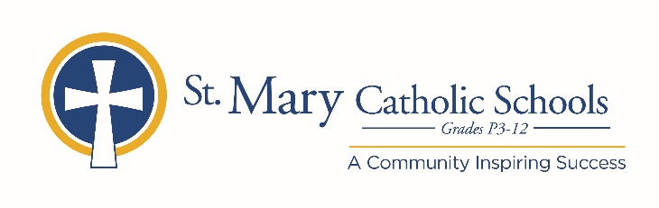

MEDIA RELEASE

October 10, 2019

FOR FURTHER INFORMATION CONTACT:
Jennifer Miller
Director of Communications
St. Mary Catholic Schools
1050 Zephyr Drive
Neenah, WI 54956
Phone: 920-722-7796 ext. 206 jmiller@smcatholicschools.org

FOR IMMEDIATE RELEASE

SMCHS Presents Radium Girls

St. Mary Catholic High School (SMCHS) is pleased to announce the upcoming fall play, Radium Girls, that will take place on November 1-2, 2019 at 7:00 p.m. and November 3, 2019 at 2:00 p.m. The play will be at SMCHS located at 1050 Zephyr Dr, Neenah and will be in the Jane Bergstrom Fine Arts Education Center. Tickets are available to purchase at SMCSFineArts.org or by calling 920-722-7796. General Admission is $12 and Student/Senior Admission is $10.

In 1926, radium was a miracle cure, Madame Curie an international celebrity, and luminous watches the latest rage—until the girls who painted them began to fall ill with a mysterious disease. Inspired by a true story, Radium Girls traces the efforts of Grace Fryer, a dial painter, as she fights for her day in court. Her chief adversary is her former employer, Arthur Roeder, an idealistic man who cannot bring himself to believe that the same element that shrinks tumors could have anything to do with the terrifying rash of illnesses among his employees. As the case goes on, however, Grace finds herself battling not just with the U.S. Radium Corporation, but with her own family and friends, who fear that her campaign for justice will backfire. Written with warmth and humor, Radium Girls is a fast-moving, highly theatrical ensemble piece for 9 to 10 actors, who play more than 30 parts—friends, co-workers, lovers, relatives, attorneys, scientists, consumer advocates, and myriad interested bystanders. Called a “powerful” and “engrossing” drama by critics, Radium Girls offers a wry, unflinching look at the peculiarly American obsessions with health, wealth, and the commercialization of science.

Students at SMCHS are diving into this period piece. The history that surrounds the story has created a wonderful learning experience for the cast and production team. The plot follows stories based on true events that will leave audiences shocked.

St. Mary Catholic High School (SMCHS) a regional high school located in the Village of Fox Crossing, Wisconsin, is part of St. Mary Catholic Schools (SMCS). The system also includes St. Mary Catholic Elementary Schools (St. Margaret Mary and St. Gabriel in Neenah, and St. Mary in Menasha), as well as St. Mary Catholic Middle School in the Village of Fox Crossing. SMCHS is dedicated to preparing and inspiring students to lead meaningful lives, rooted in the teachings of Christ in our Catholic tradition.

