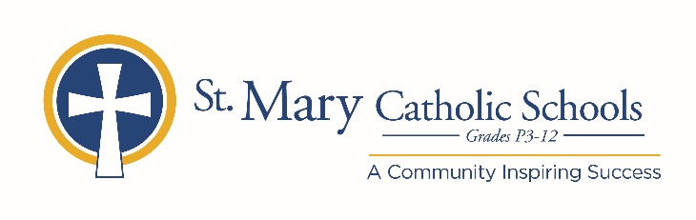

MEDIA RELEASE

October 10, 2019

FOR FURTHER INFORMATION CONTACT:
Jennifer Miller
Director of Communications
St. Mary Catholic Schools
1050 Zephyr Drive
Neenah, WI 54956
Phone: 920-722-7796 ext. 206 jmiller@smcatholicschools.org

FOR IMMEDIATE RELEASE

SMCS to Host High School and Middle School Parent Preview Nights

NEENAH/MENASHA: St. Mary Catholic Schools (SMCS) is inviting all prospective families to attend our upcoming parent preview nights.

St. Mary Catholic High School
October 29
6:30 p.m.
1050 Zephyr Drive, Neenah (enter through Ralph “Cyclone” McClone Gymnasium entrance, door #7)

St. Mary Catholic Middle School
October 30
6:30 p.m.
1000 Zephyr Drive, Neenah (enter through front doors)

Faculty, administration, and students will share information about SMCS’s academics, co-curriculars including STEM, athletics and fine arts, as well as faith and service. Check out our renovated high school commons, spectacular fine arts education center, fitness center, and state-of-the-art middle school. Learn more about our dual campus, one-to-one laptop program and how we can assist you in making our faith-based education affordable for your family.

St. Mary Catholic Schools (SMCS) includes St. Mary Catholic High School and St. Mary Catholic Middle School in the Village of Fox Crossing, Wisconsin, and St. Mary Catholic Elementary Schools (St. Margaret Mary and St. Gabriel in Neenah, and St. Mary in Menasha). SMCS is dedicated to preparing and inspiring students to lead meaningful lives, rooted in the teachings of Christ in our Catholic tradition for students in grades Pre3-12.

***end***

