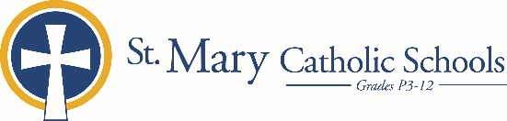

MEDIA RELEASE

September 10, 2019

FOR FURTHER INFORMATION CONTACT:
Jennifer Miller
Director of Communications
St. Mary Catholic Schools
1050 Zephyr Drive
Neenah, WI 54956
Phone: 920-722-7796 ext. 206 jmiller@smcatholicschools.org

FOR IMMEDIATE RELEASE

ST. Gabriel Elementary Presents TASTE!

NEENAH – St. Gabriel Elementary School will be hosting their annual fundraising event, TASTE!, on Friday, October 18, 2019 from 6:00-10:00 p.m. at Double Tree by Hilton in downtown Neenah.

The public is highly encouraged to attend this evening out of beer tasting paired with heavy hors d’oeuvres, desserts from local vendors, raffles, and fun! Sample more than 25 handcrafted brews and a variety of wine, soda, and coffees – a style to please every taste! There will be a silent auction with gift baskets stocked by local establishments and numerous drawings and raffles for prizes through-out the night!

This event is the school’s single largest fundraiser of the year. Tickets are $35/person in advance $40/person at the door, and can be purchased in advance by calling St. Gabriel Elementary at 920-725-4161, online at smcatholicschools.org/taste!/ or at the door. Tickets are $15 for designated drivers with full access to all food and non-alcoholic beverages.

Taste! proceeds are used by the St. Gabriel’s PTO for tuition assistance, educational enhancements, and student enrichment programs at St. Gabriel Elementary School. Past TASTE proceeds have provided educational resources such as smart boards for classrooms, playground maintenance, school office communication equipment, new desks, cafeteria tables, computers, student field trips and more!

St. Gabriel Elementary School, located in Neenah, Wisconsin, is part of St. Mary Catholic Schools (SMCS). The system also includes St. Mary Elementary in Menasha, St. Margaret Mary Elementary in Neenah, and St. Mary Catholic Middle School and St. Mary Catholic High School in the Village of Fox Crossing. SMCS is dedicated to preparing and inspiring students to lead meaningful lives, rooted in the teachings of Christ in our Catholic tradition.

***end***

