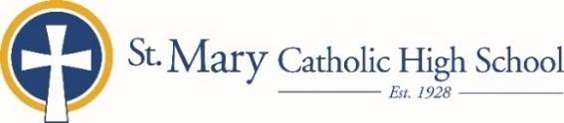

MEDIA RELEASE

September 9, 2019

FOR FURTHER INFORMATION CONTACT:
Jennifer Miller, Director of Communications
St. Mary Catholic Schools
1050 Zephyr Drive
Neenah, WI 54956
920.722.7796 ext. 206 mailto:jmiller@smcatholicschools.org

FOR IMMEDIATE RELEASE

SMCHS Welcomes Alumni for Homecoming Week Activities

Neenah--Menasha: St. Mary Catholic High School (SMCHS) encourages and welcomes all graduates to attend the school’s homecoming week activities.

Sunday, September 22: Alumni are invited to the prayer service and pep rally at Zephyrs Fields at 6:00 p.m.

Friday, September 27: The homecoming parade will start at the Tri-County Ice Arena parking lot at 5:00 p.m., proceed through the Village of Fox Crossing and end at the high school. Festivities continue with a community cookout sponsored by the Booster Club.

Alumni are encouraged to come to the following home games:

Thursday, September 26 @ 7:00 p.m. Girls Volleyball vs. Oostburg
Friday, September 27 @ 7:00 p.m. Football vs. Williams Bay
Saturday, September 28 @ 9:00 a.m. Girls Tennis vs. Clintonville, Lourdes, Mayville & SM Springs
Saturday, September 28 @ 11:00 a.m. Boys Soccer vs. Stockbridge

Contact Alumni Coordinator, Sue Peters at speters@smcatholicschools.org with questions.

St. Mary Catholic High School (SMCHS), a regional high school located in Fox Crossing, Wisconsin, is part of St. Mary Catholic Schools (SMCS). The system also includes St. Mary Elementary Schools (St. Margaret Mary and St. Gabriel in Neenah, and St. Mary in Menasha), as well as St. Mary Catholic Middle School in Neenah. SMCHS is dedicated to the individual development of each student by providing an education focused on faith, academics and service.

***end***

