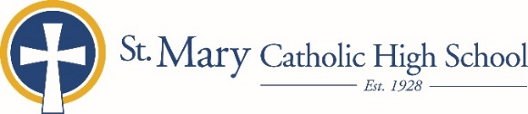

MEDIA RELEASE

September 9, 2019

FOR FURTHER INFORMATION CONTACT:
Jennifer Miller
Director of Communications
St. Mary Catholic Schools
1050 Zephyr Drive Neenah, WI 54956
Phone: 920-722-7796 ext. 206 mailto:jmiller@smcatholicschools.org

FOR IMMEDIATE RELEASE

SMCHS Approved for Global Education Achievement Certification Program

NEENAH/MENASHA: St. Mary Catholic High School (SMCHS) has been approved for the Global Scholars Certificate (GEAC) Program. This program ensures that students and staff are engaged in learning and supporting meaningful development of global competence. It promotes international leaning, global awareness, and cross-cultural connections across Wisconsin.
The GEAC is offered to St. Mary Catholic High School students who have demonstrated a strong interest in global citizenship by successfully completing a global education curriculum and engaging in co-curricular activities and experiences that foster the development of global competencies.
The Wisconsin Global Education Achievement Certificate:
- focuses and validates the excellent global education learning opportunities already in place at SMCHS
- encourages students to enroll in classes with global content in the arts, sciences and humanities
- prepares globally competent students who are career ready in Wisconsin and beyond

To earn the GEAC at St. Mary Catholic High School, students must submit a portfolio with evidence of:
- 4 HS credits of one world language
- 4 credits of coursework with a global focus (from approved list or approved by GEAC committee)
- 4 co-curricular activities or cultural events with a global focus
- 8 Cultural Literacy reflections (eight works of international /cultural media, incl. at least 4 books)
- Global service learning project (minimum of 20 hours)

St. Mary Catholic High School (SMCHS), a regional high school located in Fox Crossing, Wisconsin, is part of St. Mary Catholic Schools (SMCS). The system also includes St. Mary Elementary Schools (St. Margaret Mary and St. Gabriel in Neenah, and St. Mary in Menasha), as well as St. Mary Catholic Middle School in Neenah. SMCHS is dedicated to the individual development of each student by providing an education focused on faith, academics and service.

