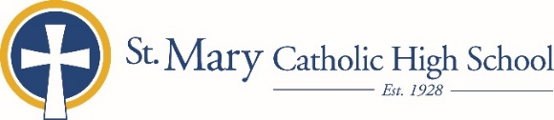

MEDIA RELEASE

September 29, 2019

FOR FURTHER INFORMATION CONTACT:
Kelly Beisenstein-Weiss, Director of Admissions
St. Mary Catholic Schools
1050 Zephyr Drive
Neenah, WI 54956
920.722.7796 ext. 157 kbweiss@smcatholicschools.org

FOR IMMEDIATE RELEASE

St. Mary Catholic High School to Offer 7th Grade Visit Day and Shadow Days

(Neenah) St. Mary Catholic High School (SMCHS) is offering a 7th-grade visit day and several shadowing opportunities for interested seventh grade students.

At the visit day on Tuesday, October 29, seventh grade students will spend the morning at St. Mary Catholic High School and will have the opportunity to meet current SMCHS students and faculty/staff, tour the school, and learn more about student life, academics, and co-curriculars.

A shadow day is the perfect opportunity for a student to gain knowledge and insight into the school atmosphere of SMCHS. These shadow opportunities are structured to give seventh graders a glimpse of high school courses, meet the faculty and allow participants the opportunity to view the school from a student's perspective. Each guest is matched with a current SMCHS student who has similar academic and co-curricular interests. Shadow days are November 11, November 12, November 18, and November 19.

Contact SMCS Early Childhood-12 Admissions Director Kelly Beisenstein-Weiss at kbweiss@smcatholicschools.org or 920-722-7796 ext. 157 with inquiries.

St. Mary Catholic High School (SMCHS), a regional high school located in Fox Crossing, Wisconsin, is part of St. Mary Catholic Schools (SMCS). The system also includes St. Mary Elementary Schools (St. Margaret Mary and St. Gabriel in Neenah, and St. Mary in Menasha), as well as St. Mary Catholic Middle School in Neenah. SMCHS is dedicated to the individual development of each student by providing an education focused on faith, academics and service.

***end***

