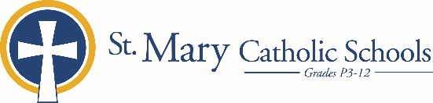

MEDIA RELEASE

October 1, 2019

FOR FURTHER INFORMATION CONTACT:
Kelly Beisenstein-Weiss, Director of Admissions
St. Mary Catholic Schools
1050 Zephyr Drive
Neenah, WI 54956
920.722.7796 ext. 157 kbweiss@smcatholicschools.org

FOR IMMEDIATE RELEASE

St. Mary Catholic Middle School to Offer 5th Grade Visit Day and Shadow Days

(Neenah) St. Mary Catholic Middle School (SMCMS) is offering a 5th-grade visit day and several shadowing opportunities for interested 5th grade students.

At the visit day on Tuesday, October 29, fifth grade students will spend the morning at St. Mary Catholic Middle School and will have the opportunity to meet current SMCMS students and faculty/staff, tour the school, and learn more about student life, academics, and co-curriculars.

A shadow day is the perfect opportunity for a student to gain knowledge and insight into the school atmosphere of SMCMS. These shadow opportunities are structured to give 5th grade students a glimpse of middle school courses, meet the faculty and allow participants the opportunity to view the school from a student's perspective. Each guest is matched with a current SMCMS student who has similar academic and co-curricular interests. Shadow days are November 11, November 12, November 18, and November 19.

Contact SMCS Early Childhood-12 Admissions Director Kelly Beisenstein-Weiss at 920-722-7796 ext. 157 or kbweiss@smcatholicschools.org with inquiries.

St. Mary Catholic Middle School (SMCMS), located in the Village of Fox Crossing, Wisconsin, is part of St. Mary Catholic Schools (SMCS). The system also includes St. Mary Catholic Elementary Schools (St. Margaret Mary and St. Gabriel in Neenah, and St. Mary in Menasha), as well as St. Mary Catholic High School in the Village of Fox Crossing. SMCMS is dedicated to preparing and inspiring students to lead meaningful lives, rooted in the teachings of Christ in our Catholic tradition.

***end***

