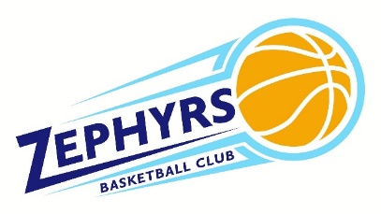
ZBC Player, Family & Coach Policy
2019-2020

Player & Family Expectations & Eligibility
Players eligible for the Zephyrs Basketball Club include:
- Registered students of the SMC School System and/or Non-SMC students who have a high interest in coming to SMC HS
- Students should not be participating in other travel/club programs at same time of ZBC season as it is expected ZBC will have full commitment of player’s basketball interest during season and if not, may be grounds for dismissal.
- Any questions to player eligibility should be addressed to ZBC Board.

All players are required to have paid registration fees and have insurance and concussion forms on file.
All ZBC families are expected to work a minimum of one shift during our ZBC 3rd/4th grade tournament. This is our club’s only fundraiser and is critical to our mission. Attendance will be recorded and addressed by the ZBC board as they see fit.
Every ZBC player and family should abide by SMC policy of acting with integrity in support of the school’s five pillars of honor. It should be known that they are representatives of the SMC school system and should act accordingly. Inappropriate behavior against coaches, officials and others will not be tolerated and could be means of removal of ZBC program without refund.
Uniforms
Jerseys will be handed out to players once payment and above papers are submitted. ZBC jerseys are required to be worn during ZBC sponsored tournaments. It is expected that the player is responsible for their ZBC issued jersey and should be returned during assigned collection days in usable condition at the end of the season. If lost or ruined, a $50 fee will be charged for a replacement.
Coach Expectations
All coaches are to be Virtus trained and one representative from each team are expected to attend one mandatory coach’s meeting before season. No checks to tournaments will be issued if a representative does not attend meeting or until make-up meeting has occurred. Responsibility for coaches include:

ZBC Head Coaches – Should set-up tournaments for teams and work with AD on scheduling practice times. They will be in charge of leading practices and games or delegating those responsibilities when unavailable. Should two teams exist per grade level, one head coach will be designated as that level’s head coach.
ZBC Assistant Coaches – Support head coach during practices and games. Fill in as head coach when needed. Minimum of 1 assistant coaches are required, with 2 or more preferred.
Team Parent, optional – Organize end of year team celebration. Works with uniform coordinator on any uniform issues and all apparel related issues.

Issues & Concerns
It is expected that all ZBC families and coaches comply with the following policy should there be any issues or concerns that arise.
Policy
No contact with coach on playing time issues until 24 hours after the final game of tournament is played.
When issue is brought up, the parent/guardian should abide by following process:
- Meet with Coach individually to discuss and understand each other’s perspective
- If not fully addressed, parent to find time to discuss issues with ZBC Boys or Girls Coordinator to discuss issue
  - Boys or Girls coordinator will then discuss issue with coach and try to rectify situation
- If not fully satisfied, parent to discuss with ZBC Board and determine course of action. Steps that may occur at this stage:
  - Observation of practice to determine behavior problems
  - Reinforcement of ZBC policies to family or coach
  - Termination of player or coach, should offense be considered severe

