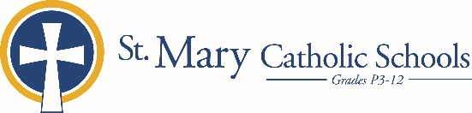

MEDIA RELEASE

August 28, 2019

FOR FURTHER INFORMATION CONTACT:
Jennifer Miller
Director of Communications
St. Mary Catholic Schools
1050 Zephyr Drive
Neenah, WI 54956
Phone: 920-722-7796 ext. 206 jmiller@smcatholicschools.org

FOR IMMEDIATE RELEASE

St. Mary Catholic Middle School Presents Meet Me in the Middle

Meet Me in the Middle is an annual fundraising event that benefits St. Mary Catholic Middle School (SMCMS). This event takes place on September 21 from 6:00-10:00 p.m. SMCS Jane Bergstrom Fine Arts Education Center. Tickets may be purchased online at: https://tcces.ejoinme.org/MyEvents/MeetMeInTheMiddle2019/tabid/1084406/Default.aspx?fbclid=IwAR0BcCUbWuvy6tkWLcDfTNqr3XIwgXUaBaNLE-5I3amEbN9RPnp7tNCtkhQ

The theme of the night is the “1980’s”and will be filled with fun 1980 style games, exciting raffles and a disk jockey playing all the biggest hits from the decade!

Tickets are $40.00 and include a wine or pint glass with drink tickets and delicious food..

The proceeds from this event will assist with the cost of technology costs, a new acoustic piano, gym and playground equipment, and classroom resources.

St. Mary Catholic Middle School (SMCMS), located in the Village of Fox Crossing, Wisconsin, is part of St. Mary Catholic Schools (SMCS). The system also includes St. Mary Catholic Elementary Schools (St. Margaret Mary and St. Gabriel in Neenah, and St. Mary in Menasha), as well as St. Mary Catholic High School in the Village of Fox Crossing. SMCMS is dedicated to preparing and inspiring students to lead meaningful lives, rooted in the teachings of Christ in our Catholic tradition.
*end*

