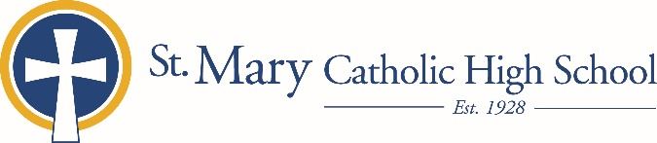

MEDIA RELEASE

August 28, 2019

FOR FURTHER INFORMATION CONTACT:
Jennifer Miller
Director of Communications
St. Mary Catholic Schools
1050 Zephyr Drive
Neenah, WI 54956
Phone: 920-722-7796 ext. 206 mailto:jmiller@smcatholicschools.org

FOR IMMEDIATE RELEASE

SMCS Announces Jaime Frink as New Director of Business Services

NEENAH/MENASHA:
St. Mary Catholic Schools (SMCS) welcomes a new Director of Business Services, Jaime Frink. Frink joins SMCS with over 25 years of experience, most recently as the director of finance with the Commonwealth Companies of Fond du Lac, WI. She will be responsible for managing all aspects of fiscal services including budgeting, accounting, payroll and financial reporting. In addition, the position oversees the SMCS business office, Scrip program, technology department and food services.
Frink graduated from Arizona State University with a bachelor’s degree in Accountancy.

“I am blessed to become part of the SMCS family,” Frink said, “I look forward to continuing to build on the financial framework that has been established by SMCS leadership by applying my nonprofit and school finance experience.”

“We were immediately attracted Jaime’s strong and diverse background in accounting and leadership,” SMCS President, Helen Englebert said. “She will make an immediate impact, assisting us in streamlining processes and creating efficiencies.”

St. Mary Catholic Schools (SMCS) includes St. Mary Catholic High School and St. Mary Catholic Middle School in the Village of Fox Crossing and St. Mary Elementary Schools (St. Margaret Mary and St. Gabriel in Neenah, and St. Mary in Menasha). SMCS is dedicated to the individual development of each student in grades Pre3-12, by providing the highest quality education focused on faith, academics and service.

