Booster Backer Memberships  A Booster Backer membership enables you to show support but also rewards you with Zephyrs apparel and spirit items, athletic passes, future apparel discounts and recognition in the Zephyrs Sports Books.  2018-19 Booster Backer Packages:  Zephyrs FANatic – $350  - 2 M.S. Adult Athletic Passes ($40)  - Big East Family Athletic Passes ($180)  - Redeem 75 “Z” Points  Coaches Club – $300  - Big East Family Athletic Passes ($180)  - Redeem 65 “Z” Points  Gold and Columbia Club – $250  - 2 Big East Adult Athletic Passes ($160)  - Redeem 40 “Z” Points  Zephyrs Grandparent – $125  - 2 Big East Senior Athletic Passes ($60)  - Redeem 25 “Z” Points  Zephyrs Cheerleader – $125  - 2 M.S. Adult Athletic Passes ($40)  - Redeem 25 “Z” Points  Zephyrs Patron – $65  - Redeem 10 “Z” Points  To view Zephyrs apparel and spirit items to select with “Z” points, please use the following link:  https://squareup.com/store/smcs-booster/  If you have any questions, please contact Tara Gagne at tgagne@smcatholicschools.org. | 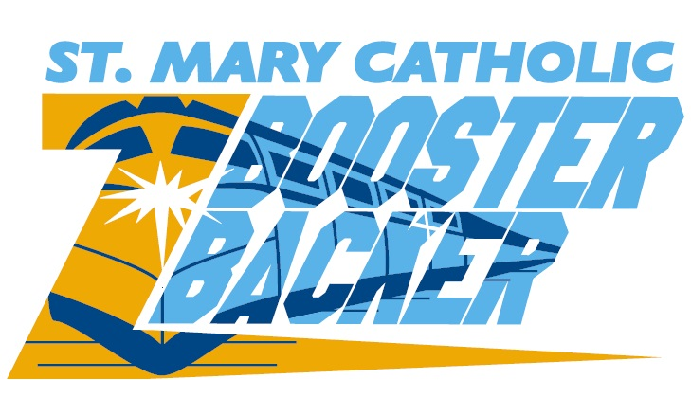  St. Mary Catholic Schools’  co-curricular activities assist in developing the whole student: one's body, mind, spirit and character through individual self-discipline, dauntless dedication, selfless efforts, the development of innate talent and abilities, sportsmanship & teamwork.  St. Mary Catholic Schools  1050 Zephyr Drive  Neenah, WI 54956  920.722.7796  smcatholicschools.org | St. Mary Catholic  Booster Club  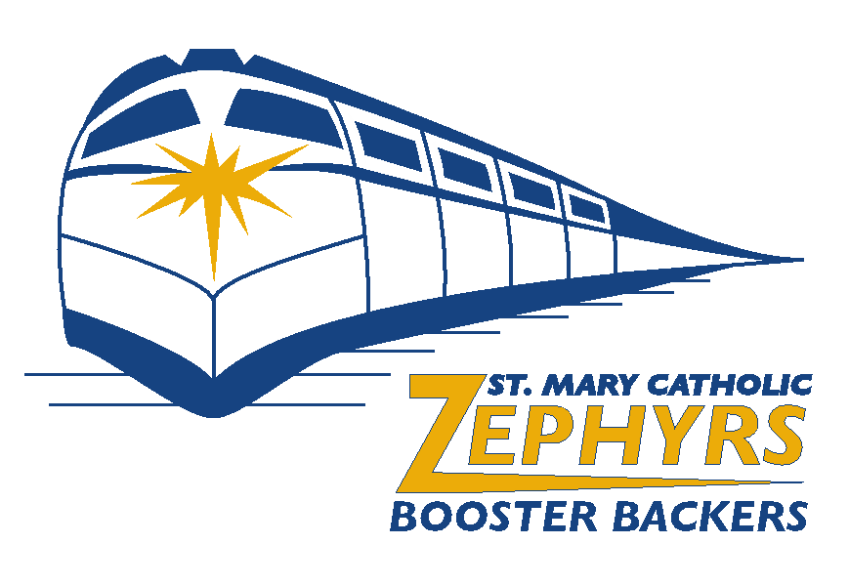  Sponsorship Opportunities
Dear St. Mary Catholic Supporter:  The SMCS Booster Club financially supports sports and co-curricular activities at the SMCS campuses. This demands more than $75,000 to be generated each year through numerous activities including concessions sales, the Greater Zephyr Open, MS basketball tournaments, Booster Backer memberships, advertisements in our Zephyrs Sports Books, and sponsorships on banners and signs.  With your support, St. Mary Catholic Schools will continue to grow their co-curricular activities. At SMCS, part of our mission is the personal development of students along with faith, academics and service. We believe participation in co-curricular activities helps develop sportsmanship, leadership and teamwork. To continue to offer these opportunities, we need your help!  Please partner with us by becoming a Booster Backer, including an advertisement in our Zephyrs Sports Books, or including a sponsorship on our banners and/or on our signs!  GO ZEPHYRS!  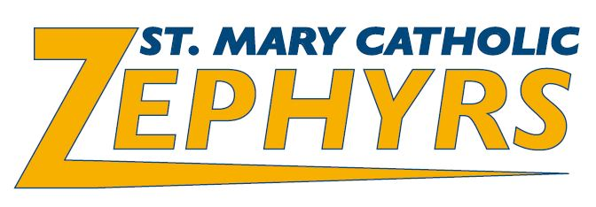  - SMCS Booster Club | Zephyrs Sports Book Ads  Full color advertisement book distributed at home sports and activities events. Published three times per year with seasonal content updates each edition. Full and half page advertisers’ logos will also appear on season schedule poster distributed throughout the community!  2019-2020 Advertisement Options:  Full Page – $800  - 5.75” wide by 8.50” tall  Half-Page Horizontal – $650  - 5.75” wide by 4.25” tall  1/4 Page Vertical – $400  - 2.75” wide by 4.25” tall  1/8 Page Horizontal – $250  - 2.75” wide by 2.00” tall  File requirements:  - PDF with outlined fonts preferred  - JPG, TIFF, PSD & EPS also acceptable  - If PDF or EPS, please outline all fonts  - Images no less than 300dpi  - Please create or convert images to CMYK (no spot or RGB colors please!)  Our first print run deadline is September 13, 2019. If you need assistance creating your ad, please contact Matt Schoultz by email at mschoultz@smcatholicschools.org. | Zephyrs Banner Sponsorships  Color banner displayed in gymnasium, baseball field, softball field, soccer/football field, SMCS STEM Building, & Riviere Tennis Center.  Indoor or outdoor banner only:  Five Years – $1,500 (total)  Four Years – $1,250  Three Years – $1,000  Two Years – $750  One Year – $500  Indoor and Outdoor Banners:  Five Years – $3,000 (total)  Four Years – $2,500  Three Years – $2,000  Two Years – $1,500  One Year – $1,000  File requirements:  - Acceptable files for logos include AI, EPS and VECTOR  If you need assistance creating your banner, please contact Matt Schoultz by email at mschoultz@smcatholicschools.org.  