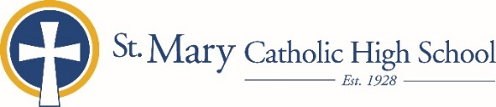

MEDIA RELEASE

July 22, 2019

FOR FURTHER INFORMATION CONTACT:
Jennifer Miller
Director of Communications
St. Mary Catholic Schools
1050 Zephyr Drive Neenah, WI 54956
Phone: 920-722-7796 ext. 206 mailto:jmiller@smcatholicschools.org

FOR IMMEDIATE RELEASE –PHOTO ATTACHED

St. Mary Catholic High School Welcomes New Campus Minister Zygmunt Gross

NEENAH/MENASHA:
St. Mary Catholic High School (SMCHS) welcomes a new Campus Minister, Zygmunt (Ziggy) Gross. Gross joins SMCHS with six years of experience in Catholic ministry, most recently with the Diocese of Green Bay. He will be responsible for building and nurturing the Catholic faith within the community and making the components of youth ministry—worship, service, justice and leadership part of the student experience.
Gross graduated from Franciscan University of Steubenville in Ohio with a bachelor’s degree in Economics. Later, while in seminary, Gross earned a bachelor’s degree in Theological and Philosophical Studies at Conception Seminary College in Missouri.

“I consider this position a great joy and opportunity to pour my own life experience and education into serving the young men and women at SMCHS,” said Zygmunt. “It wasn't until well into my twenties that I understood the powerful impact Jesus makes in my life. I hope to bring this awesome realization to the minds and hearts of students of those I encounter each day in the St. Mary Catholic Community.”

“We are very excited to welcome Ziggy on August 1 to the SMCHS family,” said SMCHS Principal, Patti Fouts. “Mr. Gross brings his experience in planning and organizing meaningful Christ centered events to the SMCHS community. We look forward to witnessing his impact by ministering our students and watching our students grow in their faith.”

St. Mary Catholic High School (SMCHS), a regional high school located in Fox Crossing, Wisconsin, is part of St. Mary Catholic Schools (SMCS). The system also includes St. Mary Elementary Schools (St. Margaret Mary and St. Gabriel in Neenah, and St. Mary in Menasha), as well as St. Mary Catholic Middle School in Neenah. SMCHS is dedicated to the individual development of each student by providing an education focused on faith, academics and service.
