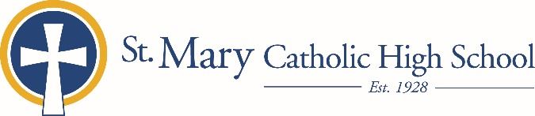

MEDIA RELEASE

July 8, 2019

FOR FURTHER INFORMATION CONTACT:
Jennifer Miller
Director of Communications
St. Mary Catholic Schools
1050 Zephyr Drive
Neenah, WI 54956
Phone: 920-722-7796 ext. 206 mailto:jmiller@smcatholicschools.org

FOR IMMEDIATE RELEASE

St. Mary Catholic High School Hosts 2019 STEM CLUB “FLY IN”

(Fox Cities): St. Mary Catholic High School is pleased to announce the SMCS STEM Club is hosting a “FLY IN” on July 19 from 9:00 a.m. to 1:00 p.m. at 1050 Zephyrs, Drive, Neenah. The date was selected to celebrate the 50th anniversary of the moon landing. This event is poised to encourage STEM and promote aviation education to students, grades 1 through 8 through hands-on and fun flight related activities.
Students will have the opportunity to pilot Camera or High Performance Racing Drones, learn about the Physics of Flight, build and launch a model rocket and just have “plane” fun by flying kites, throwing gliders, and rocket golf!
Tickets for students, 1st grade to 8th grade, are $25.00. Family members are an additional $15.00 per person. Registration is online at www.smcatholicschools.org
St. Mary Catholic High School (SMCHS), a regional high school located in Fox Crossing, Wisconsin, is part of St. Mary Catholic Schools (SMCS). The system also includes St. Mary Elementary Schools (St. Margaret Mary and St. Gabriel in Neenah, and St. Mary in Menasha), as well as St. Mary Catholic Middle School in Neenah. SMCHS is dedicated to the individual development of each student by providing an education focused on faith, academics and service.

