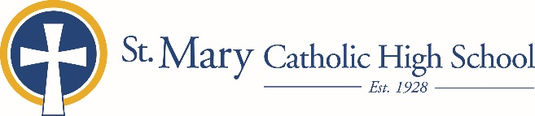

June 6, 2019

FOR FURTHER INFORMATION CONTACT:
Jennifer Miller
Director of Communications
St. Mary Catholic Schools
1050 Zephyr Drive
Neenah, WI 54956
Phone: 920-722-7796 ext. 206
jmiller@smcatholicschools.org

FOR IMMEDIATE RELEASE

SMCS FACULTY AND STAFF AWARD WINNERS ANNOUNCED

NEENAH/MENASHA: The following individuals received special recognition at the annual year-end service for St. Mary Catholic Schools’ faculty and staff. The recipients of these four annually bestowed awards were each nominated by several parents, students and/or peers. Then, an administrative committee reviewed and prayerfully considered the nominating essays and chose the finalists. A list of the comments from their supporters was given to every person who was nominated for an award.

The St. Frances Xavier Positive Influence Award was presented to Jubilee Lauterborn. In her position as a high school teacher at St. Mary Catholic High School, Lauterborn has dedicated herself to being a strong role model for her students, exemplifying what it means to face challenges with a positive attitude. She has genuine concern for her students and believes they are destined for greatness. She ensures each student receives high quality instruction and lives her faith both in and out of the classroom with a smile on her face and kindness in her actions.

The St. Anne Award for SMCS Spirit was given to St. Margaret Mary Elementary 3rd grade teacher Patrisha Hoffman . Hoffman is a positive person who is always looking on the bright side of things even when faced with challenges. She always looks for the best in everyone she meets and is so quick to offer praise and compliments to both students and staff. She shares her love of literacy in a nurturing environment with ease and is always looking for ways to bring a ray of hope to the students who are struggling the hardest.

The St. Isidore of Seville Award for Promising Innovation was given to a St. Margaret Mary Elementary 1st grade teacher, Miranda Nikolai. Nikolai shares her ideas with others and uses her knowledge to expand learning opportunities for her students. She puts in many after school hours to make sure she is fully prepared for teaching and spreads her happy spirit wherever she goes. She demonstrates dedication and innovation in Catholic education and repeatedly is the first to raise her hand when new initiatives are presented.

The St. John Baptist de la Salle Outstanding Teacher Award was presented to St. Gabriel Elementary School kindergarten teacher Maryann Slavinsky. Slavinsky is known as an incredible educator who uses positive redirection and encourages student’s faith life. She connects with each student personally, inspires all to do their best. Parents appreciate her open and detailed communication style.

St. Mary Catholic Schools (SMCS) includes St. Mary Catholic High School and St. Mary Catholic Middle School in the Village of Fox Crossing and St. Mary Elementary Schools (St. Margaret Mary and St. Gabriel in Neenah, and St. Mary in Menasha). SMCS is dedicated to the individual development of each student in grades Pre3-12, by providing the highest quality education focused on faith, academics and service.

