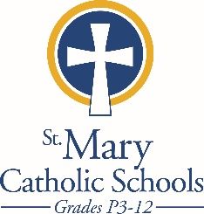

MEDIA RELEASE

March 24, 2019

FOR FURTHER INFORMATION CONTACT:
Jennifer Miller, Director of Communications
St. Mary Catholic Schools
1050 Zephyr Drive
Neenah, WI 54956
920.722.7796 ext. 206
jmiller@smcatholicschools.org

FOR IMMEDIATE RELEASE

SMCS Announces Full Day 4K for 2019-20

Neenah/Menasha: St. Mary Catholic Schools has developed a full day 4K program for the
2019-20 school year with flexible three or five day options for families. Half day 4K and three or five day P3 programs remain an option for families as well.

“We saw a need and worked to put together a program that would give additional, individualized instruction and learning time for 4K students,” stated SMCS Director of Admissions, Kelly Beisenstein Weiss. “It is a play-based curriculum that builds both math and literacy skills.”

Coupled with before and after school care and an after school enrichment program that includes STEM, sports, dance and several other options, SMCS offers an early childhood program that meets families scheduling needs.

St. Mary Catholic Schools (SMCS) includes St. Mary Catholic High School and St. Mary Catholic Middle School in the Town of Menasha and St. Mary Elementary Schools (St. Margaret Mary and St. Gabriel in Neenah, and St. Mary in Menasha). SMCS is dedicated to the individual development of each student in grades Pre3-12, by providing the highest quality education focused on faith, academics and service in a rapidly changing world.

***end***

