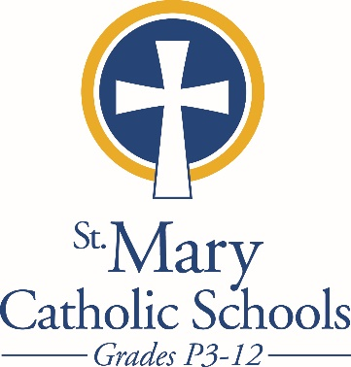

*MEDIA RELEASE*

May 2, 2018

*FOR FURTHER INFORMATION CONTACT:*

Sarah Pamer

Communications Coordinator

St. Mary Catholic Schools

1050 Zephyr Drive

Neenah, WI 54956

Phone: 920-722-7796 ext. 803

[spamer@smcatholicschools.org](mailto:spamer@smcatholicschools.org)

*FOR IMMEDIATE RELEASE*

**SMCHS Receives Nominations for PAC’s**

**Center Stage High School Musical Theater Awards**

Neenah, WI- St. Mary Catholic High School (SMCHS) is elated to announce that the high school musical, *How to Succeed in Business Without Really Trying,* has received 3 nominations from the Fox Cities PAC’s Center Stage High School Musical Theater Awards.

As described by the PAC, a team of trained adjudicators attended each participating school's musical production and provided educational feedback, ultimately determining the recipients of this year's Center Stage Awards. Scores for each production were tabulated and the top qualifiers were nominated to represent their school at the official showcase.

The nominations for SMCHS’ Musical, *How to Succeed in Business Without Really Trying* include:

**1. Outstanding Ensemble**

**2. Outstanding Performance by a Supporting Actor – Dom Lehner,**for his performance as Mr. Bratt

**3. Outstanding Performance by a Supporting Actress – Lauren Meyer,**for her performance as Smitty

The nominees will be recognized at the PAC on Saturday, **May 19 at 7:30 p.m.** where two high school students from the 17 participating schools will be chosen to participate in a professional showcase performance in New York City in June.

**St. Mary Catholic High School** (SMCHS) a regional high school located in the Village of Fox Crossing, Wisconsin, is part of [St. Mary Catholic Schools (SMCS)](http://www.smcatholicschools.org/). The system also includes St. Mary Catholic Elementary Schools (St. Margaret Mary and St. Gabriel in Neenah, and St. Mary in Menasha), as well as St. Mary Catholic Middle School in the Village of Fox Crossing. SMCHS is dedicated to the individual development of each student by providing an education focused on faith, academics and service.

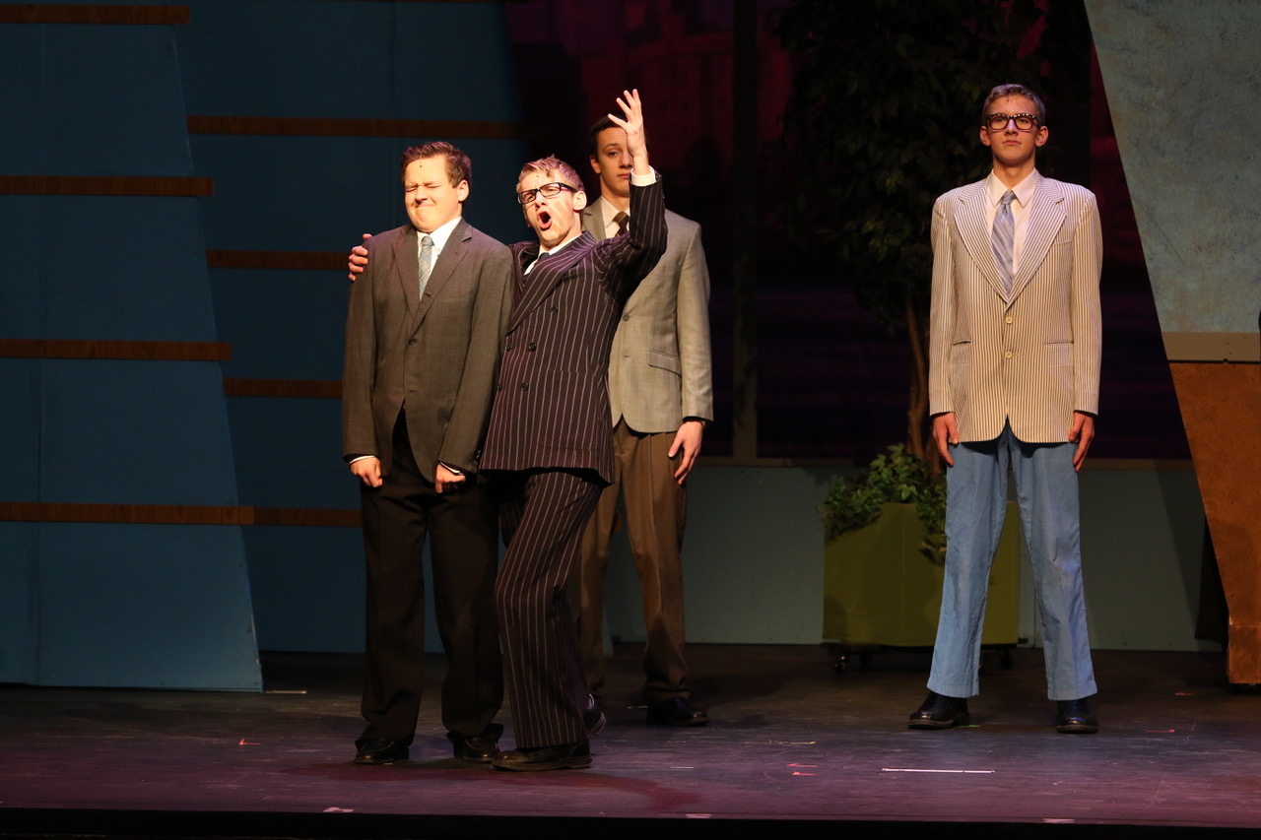

**Dom Lehner- pictured singing**

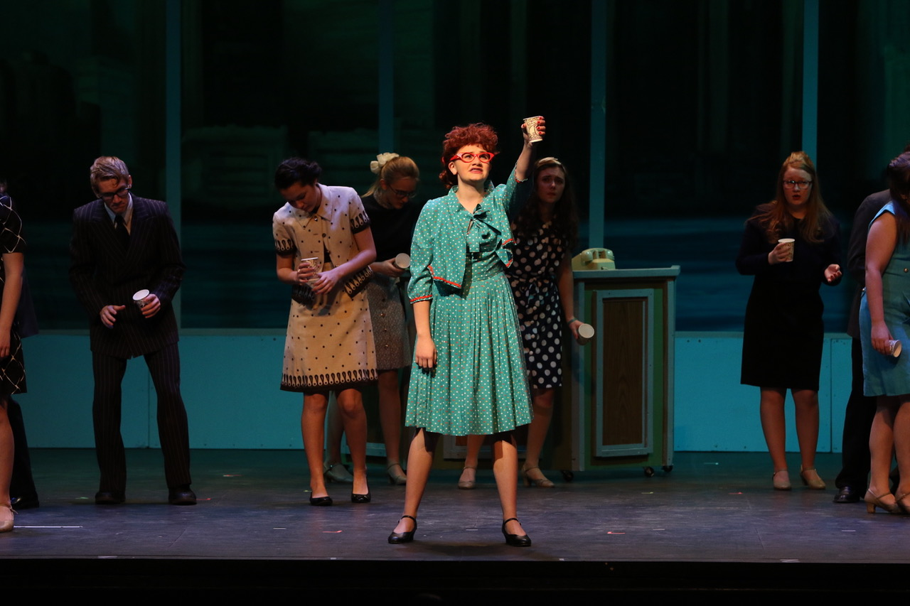

**Lauren Meyer**

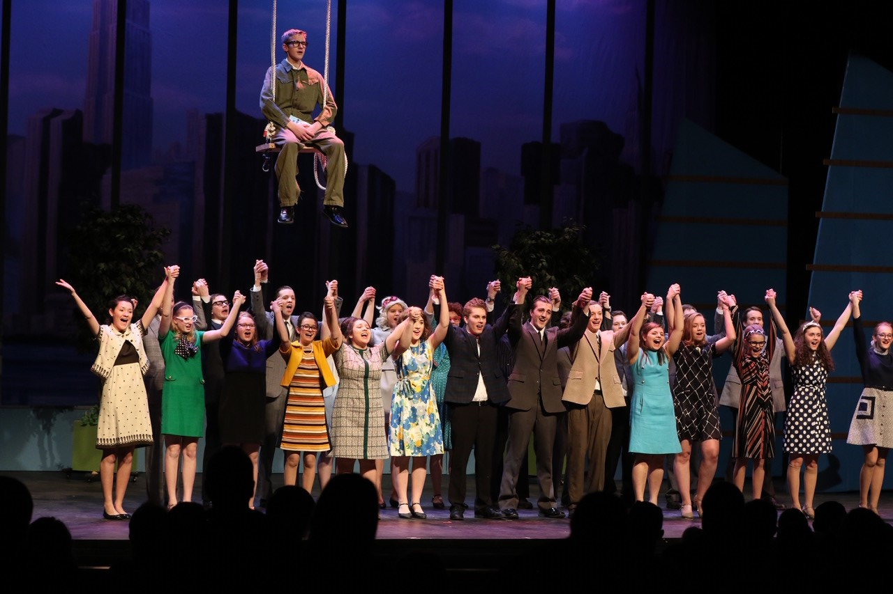

***end***