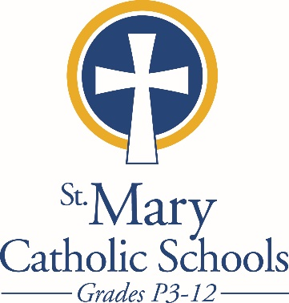

MEDIA RELEASE

May 2, 2018

FOR FURTHER INFORMATION CONTACT:
Sarah Pamer
Communications Coordinator
St. Mary Catholic Schools
1050 Zephyr Drive
Neenah, WI 54956
Phone: 920-722-7796 ext. 803
spamer@smcatholicschools.org

FOR IMMEDIATE RELEASE

SMCHS Students Excel at Solo & Ensemble Contest

St. Mary Catholic High School (SMCHS) musicians were very successful in the recent State WSMA Solo & Ensemble Festival on April 28, at UW-Oshkosh.

Ensembles earning a Rating of 1 were the SMCHS Jazz Ensemble, the Vocal Duet of Olivia Pennings and Katelyn Flanagan. The Vocal Trio of Olivia Pennings, Isabel Taubel and Katelyn Flanagan earned a 2.

Soloists earning a Rating of 1 Caroline Connolly (Alto Sax), Emma Nutini (Flute and Piano), Katie Krautkramer (Soprano), Isabel Taubel (Soprano and Music Theater), Kaylann Adler (Piano), Maria Shultz (Piano).

St. Mary Catholic High School (SMCHS) a regional high school, is part of St. Mary Catholic Schools (SMCS). The system also includes St. Mary Elementary Schools (St. Margaret Mary and St. Gabriel in Neenah, and St. Mary in Menasha), as well as St. St. Mary Catholic Middle School in Neenah. SMCHS is dedicated to the individual development of each student by providing an education focused on faith, academics and service.

***end***

