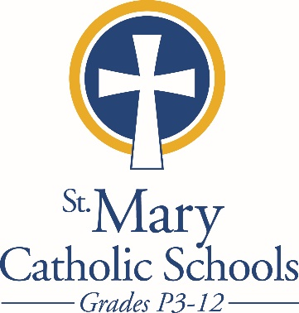

MEDIA RELEASE

April 9, 2018

FOR FURTHER INFORMATION CONTACT:
Sarah Pamer
Communications Coordinator
St. Mary Catholic Schools
1050 Zephyr Drive
Neenah, WI 54956
Phone: 920-722-7796 ext. 803
spamer@smcatholicschools.org

FOR IMMEDIATE RELEASE

SMCS Summer Day Camp & Field Trips
are Open to the Public

Neenah/Menasha: St. Mary Catholic Schools (SMCS) is so excited about its summer daycare program that they have decided to once again share the opportunity with families from outside the school system. Program Director Katie Weber stated, "We have restructured our popular summer childcare program to add an additional element of fun with new weekly themes to complement our traditional activities such as field trips and visits to the Neenah Pool, the library and other local fun spots for kids.”

Children in SMCS Summer Day Camp will participate in field trips, arts and crafts, drama, music, sports, picnics, world language and many more activities. Each week, children will enjoy events associated with a different special theme, including Down on the Farm, Under the Sea, Space, Sports and Recreation and Around the World in Five Days.

This faith-based program for children 5- to 12-years old is held at the St. Margaret Mary Campus and offers a variety of scheduling options to provide families the flexibility to meet their individual needs. The hours are Monday through Friday from 7:30 a.m. to 5:30 p.m.

SMCS Summer Camp is under the supervision of experienced and certified teachers who enthusiastically lead the children in a variety of activities and explorations, and the program’s supervisors will be onsite each day.

Students entering grades K-6 are also invited to participate in the SMCS summer field trip program, Friendsday Wednesday. A variety of field trips are offered throughout the summer and are open to all students. Seats are limited.
For details and a link to online registration, please click on Summer Childcare under SUMMER PROGRAMS at www.smcatholicschools.org, or contact Katie Weber at mailto:kweber@smcatholicschools.org Register by May 15 to guarantee space is available.

St. Mary Catholic Schools (SMCS) includes St. Mary Catholic High School and the new St. Mary Catholic Middle School in the Town of Menasha and St. Mary Elementary Schools (St. Margaret Mary and St. Gabriel in Neenah, and St. Mary in Menasha). SMCS is dedicated to the individual development of each student in grades Pre3-12, by providing the highest quality education focused on faith, academics and service in a rapidly changing world.

***end***

