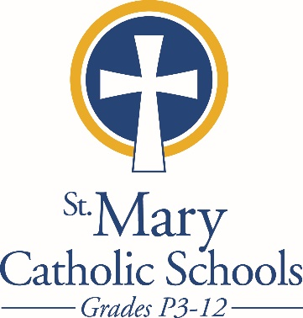

MEDIA RELEASE

April 9, 2018

FOR FURTHER INFORMATION CONTACT:
Sarah Pamer
Communications Coordinator
St. Mary Catholic Schools
1050 Zephyr Drive
Neenah, WI 54956
Phone: 920-722-7796 ext. 803
spamer@smcatholicschools.org

FOR IMMEDIATE RELEASE

SMCHS Band and Choir are Extremely Successful at
World Strides Heritage Festival in New York

Neenah/Menasha: St. Mary Catholic High School (SMCHS) Band and choirs just returned from a four day trip to New York City. While there, students had the experience of a lifetime. Whether it was on a tour and a chance to sing on stage at the Apollo Theater, seeing “Hello Dolly” on Broadway, creating a flash-mob on the streets of Times Square, or participating in a Broadway workshop with performers and musicians from “Hello Dolly,” the students of SMCS had an amazing musical adventure. Students were also able to visit, explore and celebrate Mass together at St. Patrick’s Cathedral, which is considered to be one of the most beautiful Gothic Cathedrals in the nation.

The focal point of the New York trip was the Choir and Band performance at the World Strides Heritage Festival. Competing with schools from thirteen states and Canada, both the Choir and Band were awarded Superior Gold Ratings and each placed second in their division.

The Band was presented with the Adjudicators Award, which is given based on ensemble ratings. Junior, Emma Nutini, was also recognized as a standout performer and received the Maestro Award.

Most impressive was the award received by the entire SMCS Band and Choir delegation. The Spirit Award is presented to only one school and is given to the school whose students demonstrated an outstanding level of excitement and whose interactions with one another, their directors, and the Festival staff stood out for its consistent positivity.

“Mr. Jones (Choir Director at SMCHS) and I could not be more proud of our students,” Pamela Barnhill, Band Director at SMCHS stated. “They truly represent all of the amazing things happening in the music department of SMCHS and are a wonderful reflection of what is so wonderful about the SMCS community. Thank you all for helping to make this trip possible and for supporting Band, Choir, and the Fine Arts at SMCS.”

St. Mary Catholic High School (SMCHS) a regional high school located in the Village of Fox Crossing, Wisconsin, is part of St. Mary Catholic Schools (SMCS). The system also includes St. Mary Catholic Elementary Schools (St. Margaret Mary and St. Gabriel in Neenah, and St. Mary in Menasha), as well as St. Mary Catholic Middle School in the Village of Fox Crossing. SMCHS is dedicated to the individual development of each student by providing an education focused on faith, academics and service.

***end***

