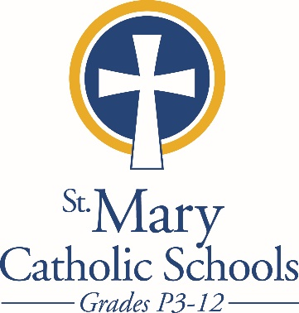

MEDIA RELEASE

April 1, 2018

FOR FURTHER INFORMATION CONTACT:
Sarah Pamer
Communications Coordinator
St. Mary Catholic Schools
1050 Zephyr Drive
Neenah, WI 54956
Phone: 920-722-7796 ext. 803
spamer@smcatholicschools.org

FOR IMMEDIATE RELEASE

St. Mary Catholic Schools Fine Arts: Zephyrs Players Community Theater Auditions Announced

Fox Cities: Community Auditions for ANNIE will take place on May 12 from noon to 3:00 p.m. at the Jane Bergstrom Fine Arts Education Center. Auditions are open to all ages and no experience is needed. Interested parties should prepare a one-minute song and may also be asked to read a small cutting from the script, which will be provided.

The Student Edition is a free program for students ages 8-16 to experience theater in an educational environment. Students will produce an abridged version of the community production and perform it twice, during the same weekend as the full community production.
Performance Dates will be July 19 - 22, also at the Jane Bergstrom Fine Arts Education Center.

The fine arts center is located on the campus of St. Mary Catholic High School, 1050 Zephyr Drive, Neenah.

For more information or to get involved with the production, please contact Hayden Kraus at hkraus@smcatholicschools.org or 722-7796 x123.

St. Mary Catholic Schools (SMCS) includes St. Mary Catholic High School and the new St. Mary Catholic Middle School in the Town of Menasha and St. Mary Elementary Schools (St. Margaret Mary and St. Gabriel in Neenah, and St. Mary in Menasha). SMCS is dedicated to the individual development of each student in grades Pre3-12, by providing the highest quality education focused on faith, academics and service in a rapidly changing world.

***end***

