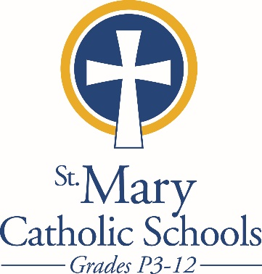

MEDIA RELEASE

February 10, 2018

FOR FURTHER INFORMATION CONTACT:
Sarah Pamer
Communications Coordinator
St. Mary Catholic Schools
1050 Zephyr Drive
Neenah, WI 54956
Phone: 920-722-7796 ext. 803
spamer@smcatholicschools.org

FOR IMMEDIATE RELEASE; graphic attached

SMCS Confucius Classroom to Host Chinese New Year Celebration

St. Mary Catholic Schools and the Confucius Classroom will welcome the Year of the Dog with a special celebration of the Chinese New Year on Saturday, February 24 from 4:00-5:30 pm. at St. Mary Catholic Middle School. The school is located at 1000 Zephyr Drive, Neenah—directly behind St. Mary Catholic High School. The event will open with a Lion Dance performance at 4:00 followed by Dragon Dance workshops, dumpling making and stations to try Chinese games, crafts and activities. The public is welcome to attend and try Chinese and a variety of activities!

Although an RSVP is not required to attend, we would like to have an idea of how many guest to expect. Please send an email to mgriffin@smcatholicschools.org to let us know if you plan to come, but know that you are encouraged to attend even if you don't RSVP!

St. Mary Catholic Schools (SMCS) includes St. Mary Catholic High School and St. Mary Catholic Middle School in the Town of Fox Crossing and St. Mary Catholic Elementary Schools (St. Margaret Mary and St. Gabriel in Neenah, and St. Mary in Menasha). SMCS is dedicated to the individual development of each student in grades Pre3-12, by providing the highest quality education focused on faith, academics and service in a rapidly changing world.
