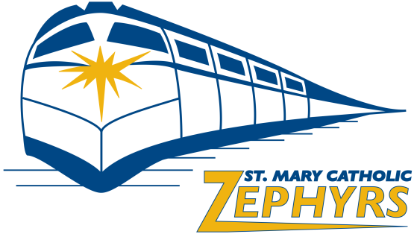
St. Mary Catholic Booster Club
02/21/2018
6:30 pm
SMC Middle School Commons

Booster Club Agenda

- Approval of Previous Meeting Minutes from 01/10/2018 – Dave Thone

- Financial Update – Adam Bates

- Athletic Director Report (High School and Middle School) – Adam Bates & Rachel Brown

- Standing Committee Chair Reports

  - Concessions:
    - Melissa Uhlenbrauck – Concession Supplier/Inventory
  - Volunteers – Pam Seidl
  - Sports/Activities Books – Jeff B.
  - Booster Backer – Tara G.
  - GZO – Craig U. & Dave T.
  - Athletic Committee – Pat B.
  - Middle School Basketball Tournaments – Al D.

- Additional Topics
  - Open

Next Meeting: Wednesday, February 21, 2018 – 6:30pm at St. Mary Catholic Middle School

